Employer Guide

How to complete the Assumed
Pensionable Pay Calculator

Version : 1.0
Owner : Aftab Malek
Author : Ammie McHugh

Contents

Introduction 3
APP Calculator – Overview 3
How to Complete the calculator 4

Introduction
This calculator is designed to assist you in the process of calculating the assumed pensionable pay (APP) based on feedback from employers. The aim of this tool is to make it easier for employers to calculate APP in line with the LGPS regulations, ensuring the accuracy of the information provided and a consistent approach.

APP Calculator – Overview

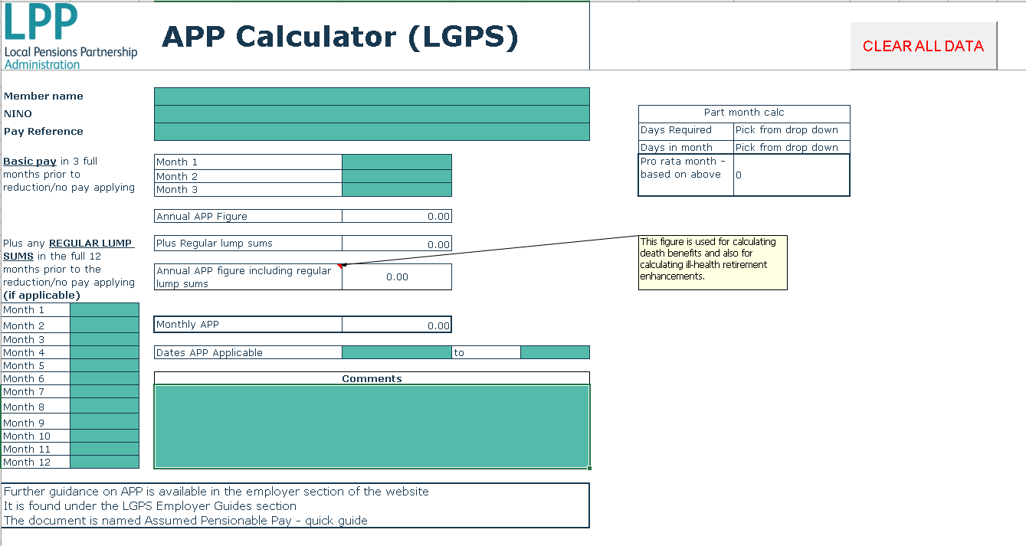

The above is an overview of the calculator. There are basic member details fields available at the top, should you wish to use the calculator and send us a copy of your calculation.

How to Complete the calculator

Once you have identified when the member went on to reduced or no pay, you need to identify the full 3 months prior to this point.

Example if the member went on to reduced pay from 14/02/20, the 3 full months prior to this point are November 2019, December 2019 and January 2020.

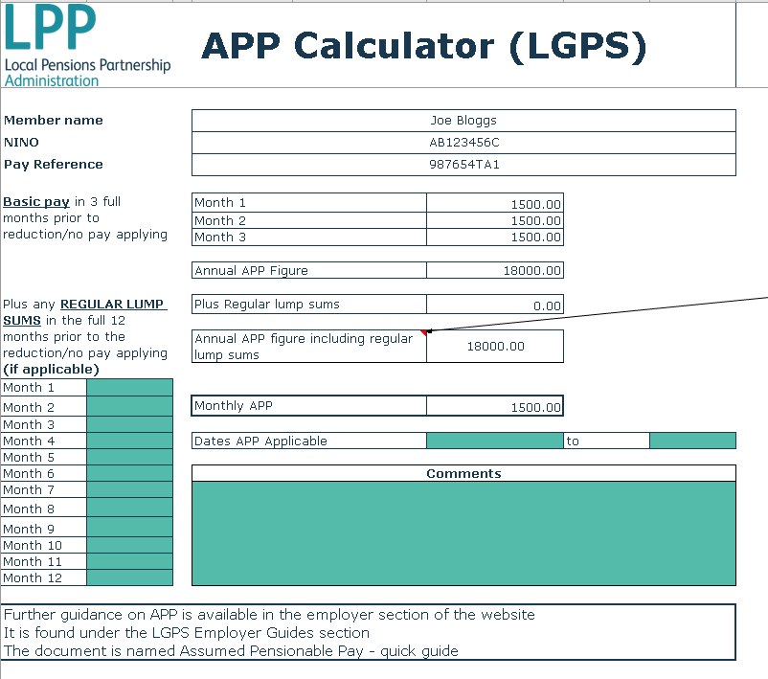
You need to input the basic pay (salary) amounts in the red boxes highlighted.
DO NOT include any regular extras here, as this will result in the APP being calculated wrongly. Regular extras are accounted separately, and we will cover this later.

As you can see, based on the example above, the pay in November 2019, December 2019 and January 2019 was £1500 per month. Using this information, the calculator will work out the Annual APP amount and the monthly amount, in this case it is also £1500 per month.

If the member was paid regular extras in the 12 months prior to the reduction/no pay applying, these need to be recorded separately, as these should be included for the purposes of calculating APP. Regular extras tend to be payments for things like First Aid, Stand-by allowances, weekend and night duties etc.

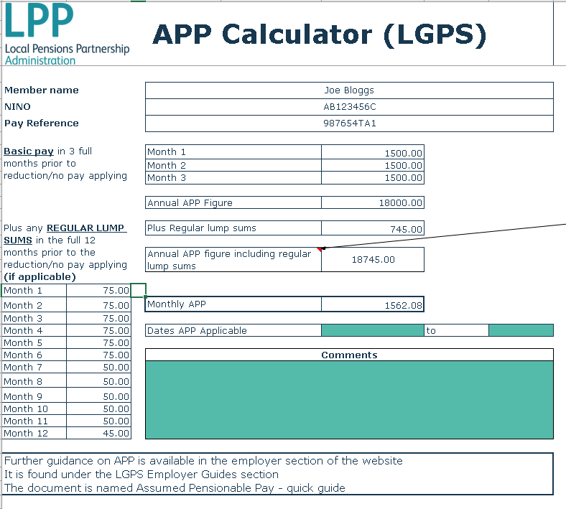
Using the example from earlier, this member’s 12 months period prior to the reduction runs from February 2018 through to January 2019. The member was paid regular extras in each of those months, which need to be entered in the red boxes highlighted. The calculator will calculate the total amount input here and calculates a total for these on the right side of the calculator.

This is then added to the Annual APP figure calculated earlier and calculates an Annual Figure including the regular lump sums. This is then divided by 12, to get a monthly APP amount.

The calculator is also set-up to allow you to do part month calculations, where applicable. Continuing to use the example above, the member went on to reduced pay from the 15th February 2020. So, the APP applicable for February will only be for 15 days based on 15 days from 15th February 2020 to 29th February 2020.

This is calculated using the part month calculator function, at the bottom right hand side. This is based on a drop-down list, which allows you to pick how many days are required and the number of days in the month.

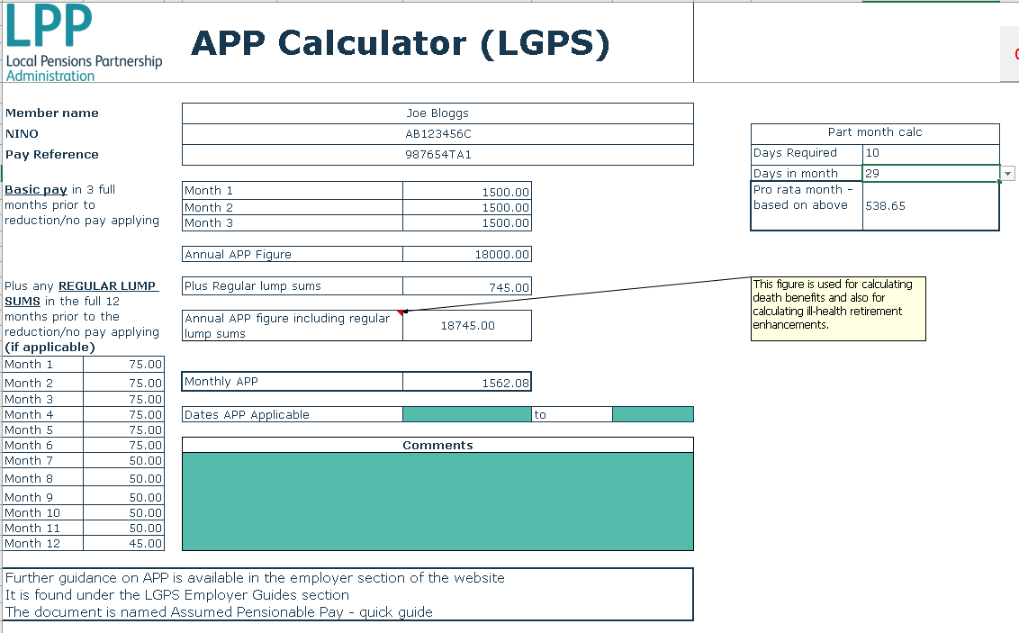

See the red box highlighted above.

Using the example case here, the member’s CARE pay for pension purposes here is based on 2 parts. The first part is based on them receiving their normal rate of pay from 1st February
2020 – 14th February 2020 @ £1500 per month, which equates to £1500/29* 14 = £724.14 PLUS the second part based on the pro-rata APP we have calculated for the member, which applies from 15th February 2020 amounting to £538.65. Therefore, the CARE pay for February 2020 should be reported as £724.14 + £538.65 = £1262.79.

For convenience and ease of use, there is also a button to “clear all data” on the calculator. By using this, all the input fields, can be cleared in at the push of a button.

The dates APP applicable fields require a date inputting using the following format DD/MM/YYYY. The dates here are just the dates that the APP applies from and to i.e. when they went on to reduced or no pay.

The comments box here is to allow for you to include any additional information, a break down of any part months, like the example above where APP applies for part of the month and they have returned to employment and full pay for the remainder of it.

